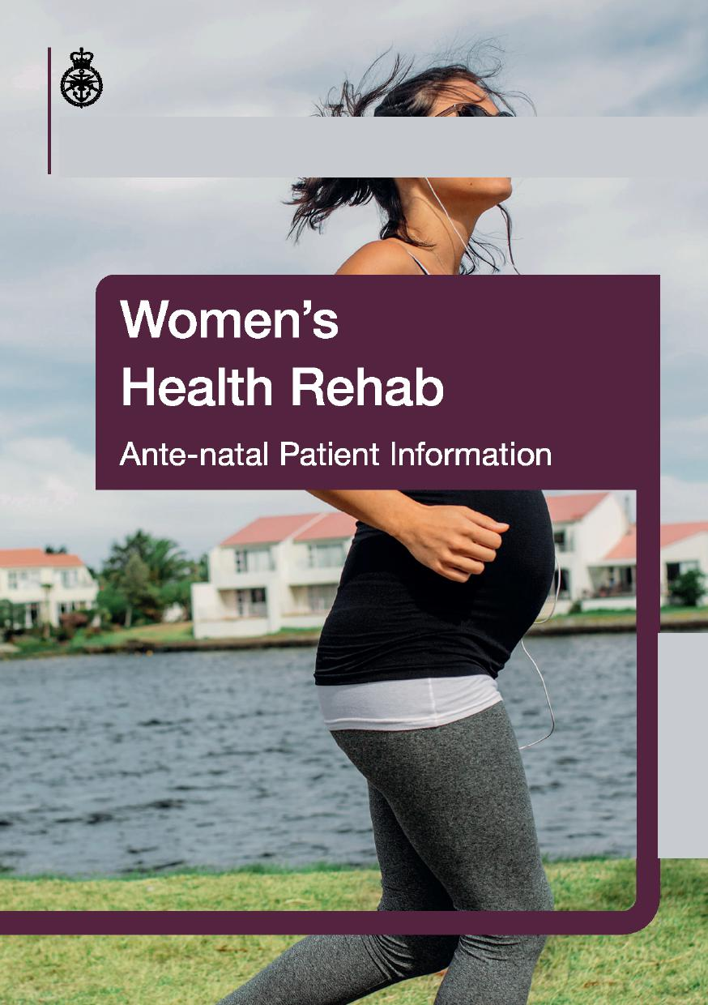




Body Changes During Pregnancy
Many changes happen to the body throughout pregnancy. This is a normal process that allows the body to nurture the developing foetus and prepare for labour. Being aware of them and how they affect you will allow you to continue with your everyday activities without risk of injury.
Postural Changes
As the baby grows, and the breasts become larger, the centre-of-gravity (COG) moves further forward. Although gradual, this change in COG can affect a mother's balance and cause an increase in both lumbar and thoracic curves.
Muscle Stretching
As the baby grows, the abdominal muscles stretch to accommodate.
Because they are stretched, they become less efficient at supporting your lower
back. The increasing size and weight of the baby, increases the amount of
pressure and stretch on the pelvic floor muscles.
Softening of Ligaments

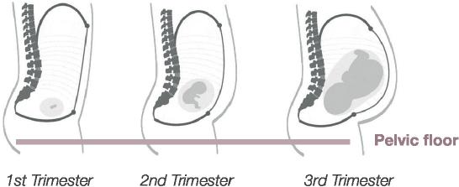
1st Trimester
2nd Trimester
3rd Trimester
Pelvic floor
An increase in hormones, like progesterone, assist in increasing mobility of joints around the pelvis for labour and birth. As the ligaments soften, the joints become less stable - the resultant increase in movement may lead to pain in your back and pelvis.
Exercise in Pregnancy
Exercise in pregnancy is both safe and beneficial to the health of mum and baby. See the recommendations in the picture opposite. Your MO will guide you to who is best placed to provide you with further information based on your individual needs or medical status.

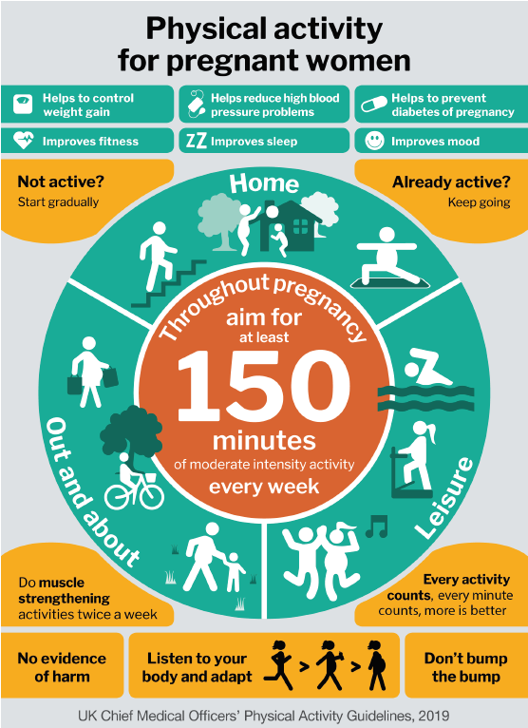
- Transversus Abdominus - in four point kneeling, gently draw your tummy button up towards your spine. Hold for 15 seconds and repeat 10 times.
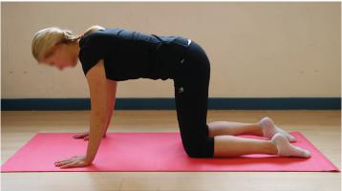

- Seated Rotation - sit tall in a chair with the feet flat on the floor and the arms crossed over the chest. Slowly look over your shoulder and twist the torso in the same direction. Hold this position for a breath in before returning to the start position. Repeat on the opposite side. Repeat 10 times.
- Seated Mermaid - sit tall in a chair with the feet on the floor. Raise one arm out to the side and up over your head, allowing your spine to bend. Hold the position for a breath in before floating the arm back down. Repeat on the opposite side. Repeat 10 times.

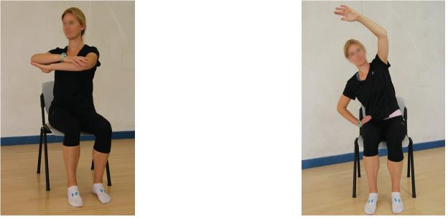

- Child Pose - from all fours drop the hips backwards to rest on your heels. Stretch the arms out along the floor. You may need to separate your knees to accommodate your bump. Relax in this position for several breaths.
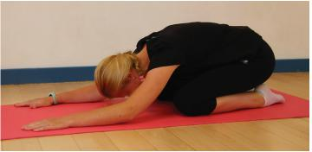

- Thread the Needle - on all fours reach your hand through the opposite arm/leg allowing the spine to rotate. Perform on both sides. Repeat 10 times.
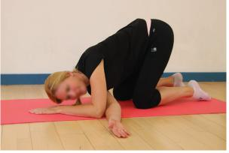
- Pelvic Tilting in 4 Point Kneeling - in 4 point kneeling tilt your pelvis to flatten the curve of the lower back, then tilt it in the other direction to increase the curve. Repeat 10 times.

- Wall Ball Squat - stand with your feet hip width apart and the gym ball between your back and the wall. Slowly lower down into a small squat then push through the heels and squeeze your gluts to come back up to standing. Repeat 10 times.
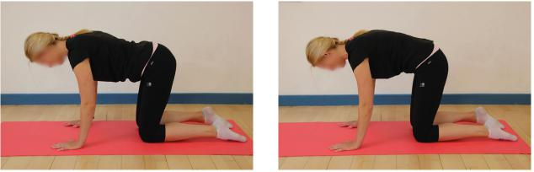
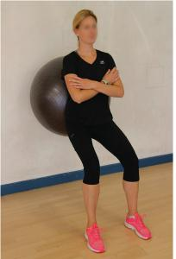
- Sit to Stand from a Chair - start seated in the chair with the feet on the floor hip distance apart. Lean forward with the arms out, push through your feet squeezing your gluts as you stand. Slowly return to sitting aiming to sit as far back in the chair as possible. Try not to use your arms.
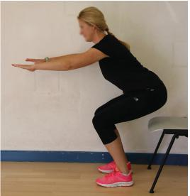

- Low to High Kneeling with Arm Elevation - kneeling on the floor cross the arms and take an end of TheraBand in each hand. Keeping the tummy drawn in, move from low kneeling to high kneeling at you move the arms up and outwards above the head. Try to keep the curve of the lower back to a minimum.

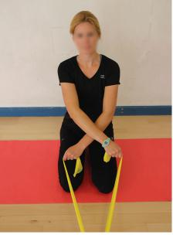
- Happy Cat Angry Cat - in four point kneeling curve your spine starting from the pelvis all the way to the neck. Slowly curve the spine in the opposite direction. Repeat 10 times.
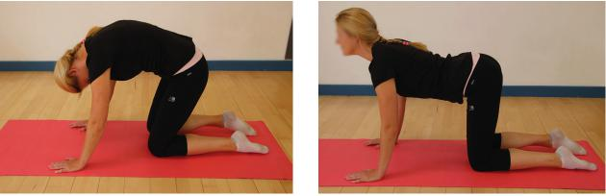
Pelvic Floor Exercises
Please see separate leaflet for information and advice on Pelvic Floor, including how to exercise your pelvic floor. Ask your physio, MO or PTI for a copy.
Tips to Avoid Stress and Strain
- Sit with a good posture.
- Consider sitting when ironing, preparing food etc.
- Carry bags equally in both hands - avoid 'lopsided' carrying. Consider using a rucksack instead of a handbag.
- If you have a toddler, avoid carrying them on one hip. If you have to, then alternate sides.
- Keep your legs together as you get out of the car or roll over in bed.
- Use correct lifting techniques.
- Activating your transverse abdominus muscle (as shown in the earlier exercise)
during lifting, pushing and pulling movements will help support your spine
and pelvis.
Pelvic Girdle Pain (PGP)
PGP (formerly known as Symphysis Pubis Dysfunction or SPD) is the name given to a group of symptoms or pain in the joints in the front and / or back of your pelvis. It can start at any stage of your pregnancy.
Common symptoms are:
- Pain walking and sitting.
- Difficulty climbing stairs.
- Pain and difficulty turning over in bed.
- Having to sit down to get dressed.
Your physiotherapist can give you further advice if you think you are
experiencing PGP (access via self referral or your MO). Please also refer to
the separate information leaflet: 'Pelvic girdle pain and pregnancy'
Pelvic Girdle Pain in Pregnancy - RCOG PIL: www.rcog.org.uk/globalassets/documents/ patients/patient-information-leaflets/pregnancy/pi-pelvic-girdle-pain-and-pregnancy.pdf
Other Common Problems
Constipation
Hormonal changes reduce gut motility, leading to constipation. Any subsequent straining increases stress on the pelvic floor. Sitting on the toilet with the knees higher than the hips and leaning forward can help to empty the bowel. Drinking plenty of fluids (1.5-2 litres per day, water is best) and eating a balanced diet containing fibre, will help prevent constipation. If necessary speak to your MO about medication which can help to keep your bowels moving.
Leg Cramps
These can occur due to the changes in body chemistry and abdominal pressure.
Exercising your feet before going to bed can help.
- Ankle circles 10 times each way briskly.
- Calf stretches
- Massaging the calf muscles
Swollen Ankles and Varicose Veins
From about 16 weeks try not to lie flat on your back. Try resting on your left side with your legs slightly bent. Briskly move your feet up and down for 30 seconds every hour or so. Avoid standing for long periods of time and consider wearing support tights.
Carpal Tunnel Syndrome
This occurs due to the extra fluid in your body causing an increased pressure at the wrist. This can cause numbness and tingling in the hands and fingers. It is often more of a problem at night or first thing in the morning. Your physiotherapist may supply you with wrist supports to wear at night, which can help to reduce the symptoms. These symptoms normally resolve postnatally.
**If swollen ankles and/or fingers are accompanied by a puffy face,
headaches or flashing lights, seek medical advice immediately**
Self-management of carpal tunnel syndrome:
- Elevate arms with cushions/pillows whenever possible to help reduce the swelling.
- Apply an ice pack for 10-15mins, 3-4 x daily.
- Some medication may help your pain but speak to your MO to see which is safe to take in pregnancy.
- Wear a wrist splint if supplied by your physiotherapist.
- Try to keep the wrist in a neutral position, avoiding positions which cause you to repeatedly bend your wrist or grip hard.
- Avoid heavy lifting or repetitive activities such as typing.
Rib Pain
As your baby grows it pushes against your rib cage, this can cause some discomfort over your lower ribs. Try to change your position regularly and avoid sitting in low chairs. You might find it helpful to lift the arm on the painful side up and bend sideways away from the ache.
Further Information
Mitchell method of relaxation: https://pogp.csp.org.uk/system/files/ publication_files/POGP-Mitchell.pdf
Pelvic, Obstetric and Gynaecological Physiotherapy (POGP): www.pogp.csp.org.uk
Royal College of Obstetricians and Gynaecologists: www.rcog.org.uk

Creative Media Design ADR008969

